

Done by Sulaiman Alsharji

**Idea**

Platform that providing service and product through interior designing due process until the final product which enhanced via process by AI coaching.

**Problem**

Not having software which can design until making final product that cost longer time, less productivity and more expensive, from anywhere.

**Solution**

Software which enhances productive processes via Designing, modeling and final product from anywhere through execution via smart contract and pay digitally.

**Co-founders team structure**

**Addressed Significant Pain**

**Non-obvious/creativity/disruptive**

Designer is interior design platform and app, based on high technology IT services to provide user with software that finish the final product accord processes of designing, modeling to final product by providing very creative, simple, skillful and accurate tools. The software will be developed to serve big number of people and market whether locally or internationally around the world. It will be disrupted with an advance technology like, AI, ML, IoT, Blockchain and smart contract to maximize productivity, innovation, design options, reducing time and cost. As well we satisfy our customers buy enhancing 3D printer service to innovate high quality interior design product. The big solution comes from providing opportunity of having the product of their taste by brokerage between customer, material supplier and manufacture. Coaching via robotic artificial intelligence by using data to help users, active advises, augments our learning. Our software executes the final product after prototyping and testing it to be developed as final product. We are selling via brokerage between us and customer to execute the final product. The designer offers their customers to design their final product with 30% OFF for the second one due to same payment from the launch of startup.



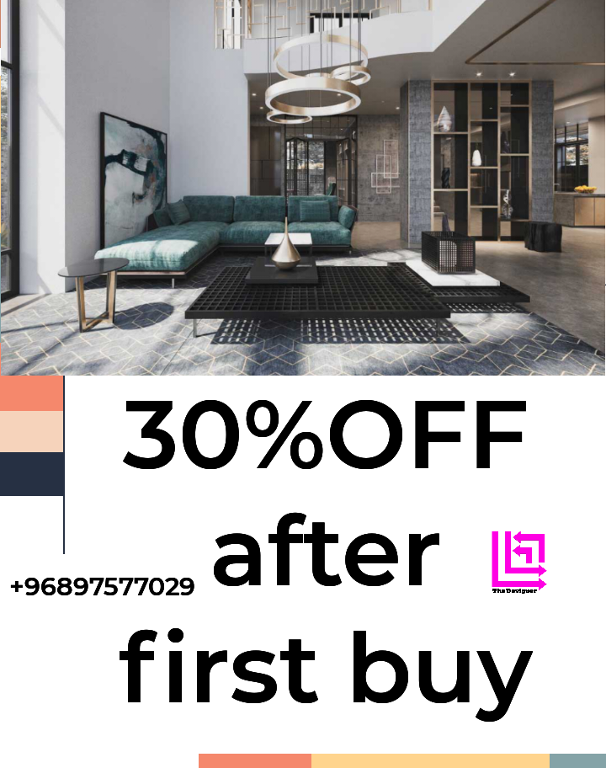

**Market Plan**

|  |  |  |
| --- | --- | --- |
| *Before buy (design)goal customer know about my product and service* | *During buy (after design) customer happy and buy from us* | *After buy (final product) goal great trust between us and customer* |
| * Our targeted users are these who are buying our interior design product and services accord to demographic which mostly between 18 - 60 years, with sufficient income, mostly are people who looking and feeling of internal space and fashion, some of them singles but, most of them married or new to marriage , from all countries and both of women and men. * The most targeted industries, commercial interior design, Sustainable interior design, Restoring, Classroom interior design, production interior design, visual merchandiser, Exhibition, interior decorator, Antique artifacts restoring, events and holiday decoration, interior landscaping and lightening design. As well the coverage including Sultanate of Oman and the world market. | * Identify goals capable to be measured and implemented with data demography. * The growth of customer due to knowing our appropriate market of our product and services, knowing the size of market, what our product and service solve. * Conversion rate = Purchasing customer/Total visitors the formula which giving us an insights about our successful level accord to marketing. | * Easy use, positive interaction, communication, high quality, product and service. * CLV based on feedback, cross sell or up sell, sales and onboarding processes optimization. * Best ways to reach market and customers are social media, ads, media, events and broad relationship either wirelessly or physically. |

**How to attract the market and targeted audience**

**Market size, scalability and level of competition**

-TAM of designer is 20$ billons out of 30 % of total sales which equal 20B$ X 0.3 = 6B$ and 25% of sales executed digitally which 6B$ X 0.25 = 1.5B$, by that TAM is 1.5 billion USD.-SAM is out of TAM by 25% which 1.5B$ X 0.25 = 375M$, Based on that SAM is 375M$. -SOM is out of SAM by 5% which 375M$ X 0.05 = 18.75M$ accord to that SOM is 18.75M$.

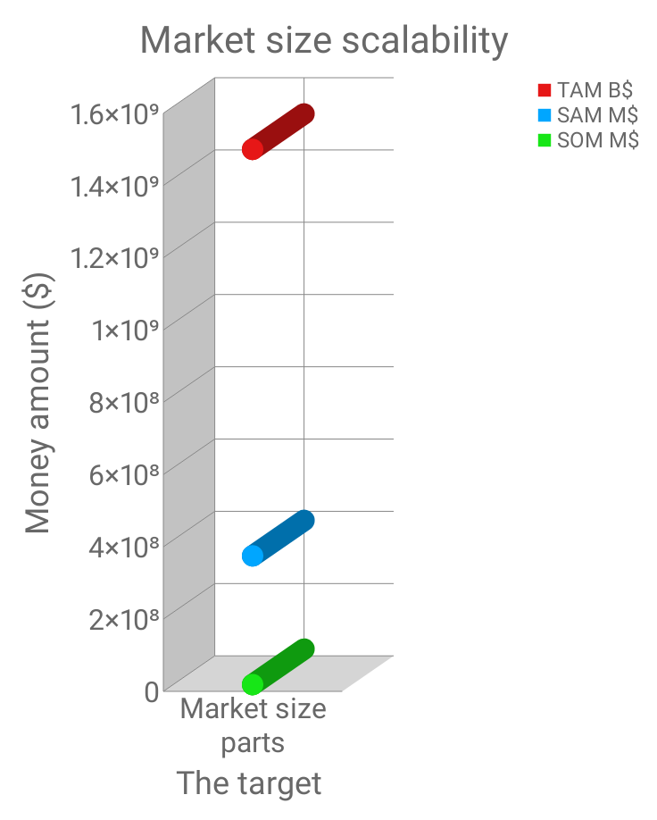

|  |  |  |  |
| --- | --- | --- | --- |
| Comparison type | Competitor Company 1 | Competitor Company 2 | Our company |
| Designing tools | Available | Available | Available |
| Modeling | Available |  | Available |
| AI coach and consultancy |  |  | Available |
| Final product |  |  | Available |
| Digital marketing | Available | Available | Available |
| 3D Printer |  |  | Available |
| Digital customer support |  | Available | Available |

**What makes the project unique attractive offer and winning the customer?**

**Customer attraction strategy (Get, Keep and Grow)**

**SMART form of the designer**

|  |  |
| --- | --- |
| S | To provide customer both of service and product from designing until the final product from anywhere. |
| M | Maximizing the number of customer up to 31% within a year. |
| A | Reaching very advance level of designer software within 1 year. |
| R | Highly matching the requirement of market and customer. |
| T | Making very quality accurate measurement plus evaluation every 6 months. |

**Value proposition value**

|  |  |  |  |  |
| --- | --- | --- | --- | --- |
| PRODUCTS/SERVICES  - Interior design  - Modelling  - Final product | GAIN CREATORS  - AI coaching and consultancy  - AI and employee broker to reach final product  - Ace of designing tools |  | GAINS  -Brand awareness  Design  - Model  - Perform innovatively and precisely  - Final product of personal test | CUSTOMER JOBS  - Booming revenue based on wide marketing  - Activating the platform community  - Adding valuable customer service |
| PAIN RELIEVERS  - Very supportive Chabot  - Creative AI coaching and consultancy  - Trust and transparent  -Blockchain & Smart contract  - Quick smooth process | PAINS  - Technical problems  - No sufficient service  - Not understanding well |

**Business model canvas**

|  |  |  |  |  |  |
| --- | --- | --- | --- | --- | --- |
| **KEY PARTNERS**  - Investors  - Media producer  - Google cloud  - Brokerage  - Manufacturer  - Smart contract | **KEY ACTIVITIES**  - Designing, modelling and final product  - Distribution  -Marketing and sales | **VALUE PROPOSITION**  - 24/7 on demand  - Plenty access  - Interior design  - Customer service | | **CUSTOMER RELATIONSHIP**  - Use ease  - On demand  - Self service | **CUSTOMER SEGMENTS**  - Demographic segmentation  - Geographic segmentation  - Behavioural segmentation  -Psychographic segmentation |
| **KEY RESOURCES**  - Brand  - Website  - Platform  - Employees | **CHANNELS**  - Online advertising  - Chatbot  - Social media  - Any device |
| **COST STRUCTURE**  - Administration  - Marketing and sales  - Licensing  - Payment process fees | | | **REVENUE STREAM(S)**  - Designing and modelling revenue  - Ad revenue  - Providing final product | | |

**(ROI) Potential**

Costs initial year

|  |  |
| --- | --- |
| Software developing | 5000 |
| Office equipment | 2000 |
| Salaries | 33700 |
| Life cover scheme | 2000 |
| Rent | 2000 |
| IT, mobile phones and Wi-Fi | 300 |
| Local tax | 2500 |
| Bank charges | 300 |
| Utilities | 2200 |
| Total Expenses ($) | 50000 |
|  |  |
| |  |  | | --- | --- | | Net Sales (Gross Revenue) | 120000 | | Cost of sales | 10000 | | Net Revenue ($) | 110000 | |  |

ROI = Revenue - Expenses / Expenses X 100

ROI = (110000 – 50000) / 50000 X 100 = 120%

**Technology**

The designer bonded with AI, ML, IoT, Blockchain and smart contract are to maximize productivity, innovation, design options, reducing time and cost.

Reference

* Lewrick, M. (2018). The Design Thinking Playbook: Mindful Digital Transformation of Teams, Products, Service: Willey.
* Rogers, D. (2016). The Digital Transformation Playbook: Rethink Your Business for the Digital Age.
* Perkin, N. and Abraham, B. (2017). Building the Agile Business through Digital Transformation: How to Lead Digital Transformation in You.
* Stickdorn, M. (January 2, 2018.). This is service design doing: applying service design thinking in the real world: a practitioner’s handbook.
* [Online]. Available from: <https://99designs.com/blog/web-digital/how-to-design-an-app/>
* [Online]. Available from: <https://www.designrush.com/best-designs/apps>
* Prior, P. (2017). Your First CFO The Accounting cure For Small Business: KBO Sales, Inc.
* Cohan, P (2019). Scaling Your Startup: Mastering the Four Stages from Idea to $10 Billion: Apress.
* Theil, P. and Masters, B. (2014). Zero to One: Notes on Startups, or How to Build the Future: Ebury Publishing.
* Templar, R. (2012). The Rules of Money: How to Make It and How to Hold on to It : FT Press.
* Greber, M. (2008). Awakening the Entrepreneur Within: How Ordinary People Can Create Extraordinary Companies: Harper business.
* Reeves, M. & Haanaes, K. & Sinha, J. (2015). Your Strategy Needs A Strategy: How to choose and Execute the right approach, Harvard Business Review Press.
* Meadows, M. (2017). The Ultimate Focus Strategy: How To Set The Right Goals Develops Power Focus, Stick To The Process, AND Achieve Success: Meadows Publishing.
* Bhargava, R. (January 7, 2020). Non Obvious Megatrends: How to See What Others Miss and Predict the Future (Non-Obvious Trends, 10): Ideapress.
* Gutsche, J. (March 10. 2020). Create the Future: Tactics for Disruptive Thinking: Fast Company Pr.
* [Online]. Available from: https://www.grayfox.co/canvas-models/value-propostion-canvas-guide/
* [Online]. Available from: <https://www.adobe.com/mena_ar/creativecloud/business/teams/use-case/6-ways-to-aquire-new-customers.html>
* عبدالرحمن الحضيري .(1 نوفمبر, 2021) إقناع المستثمرين: العرض الفعال لجذب المستثمرين الإستثمار, دار النشر: عبدالرحمن الحضيري